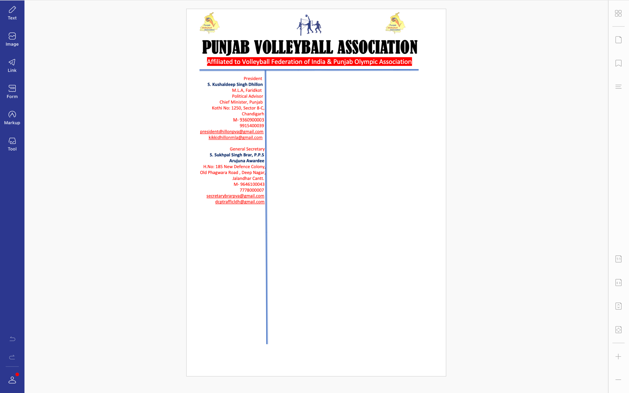



**Ref. PVA/BRAR/2021/Spl.-(2)/2010** Dated: 20-09-2021

v`l:

____________

____________

ivSw: sInIAr styt vwlIbwl cYNpIAniSp (mrd Aqy AorqW) iv`c rYPrI borf Aqy qknIkI kmytI sbMDI

auprokq ivSy dy sbMD iv`c Awp jI nUM bynqI kIqI jWdI hY ik

sInIAr styt vwlIbwl cYNpIAniSp (mrd Aqy AorqW) jo ik izlwH vwlIbwl AYsosIeySn, PrIdkot v``loN imqI 1,2 Aqy 3 AkqUbr, 2021 idn Surkvwr, SnIvwr Aqy AYqvwr nUM PrIdkot ivKy krvweI jw rhI hY [ ies tUrnwmYNt hyT ilKy Anuswr rYPrI borf Aqy qknIkI kmytI dw gTn kIqw jWdw hY-

1. S. gurbKS isMG, jlMDr cyArmYn

2. S. jgdIp isMG, SRI PiqhgVH swihb mYNbr

2 s. mnoj kumwr, sMgrUr mYNbr

DMnvwd sihq

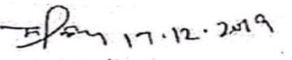

suKpwl isMG brwV, Arujnw AvwrfI

jnrl sk`qr

pMjwb vwlIbwl AYsoSIeySn